**DAILY ONLINE ACTIVITIES SUMMARY**

|  |  |  |  |  |  |  |  |  |
| --- | --- | --- | --- | --- | --- | --- | --- | --- |
| **Date:** | **29/06/2020** | | | | | **Name:** | **Lavanya D M** | |
| **Sem & Sec** | **4th & ‘A’** | | | | | **USN:** | **4al18cs041** | |
| **Online Test Summary** | | | | | | | | |
| **Subject** | | **----** | | | | | | |
| **Max. Marks** | | **----** | | **Score** | | | **-----** | |
| **Certification Course Summary** | | | | | | | | |
| **Course** | EIGRP Course | | | | | | | |
| **Certificate Provider** | | | **Bitdegree** | | **Duration** | | | **1week** |
| **Coding Challenges** | | | | | | | | |
| **Problem Statement:**  1) Given a list of numbers, write a Python program to count Even and Odd numbers in a List.  2)**Java program to Print Hollow Inverted Pyramid Star Pattern** | | | | | | | | |
| **Status: Complied** | | | | | | | | |
| **Uploaded the report in Github** | | | | | **yes** | | | |
| **If yes Repository name** | | | | | <https://github.com/lavanyamurthi/lockdown-coding> | | | |
| **Uploaded the report in slack** | | | | | **yes** | | | |

Online Test Details: (Attach the snapshot and briefly write the report for the same)

No test conducted

Webinar:

Today class is conducted on Cyber security by Manjunath sir in which we learn about the concept of Cyber security , and even we had quiz regarding that

Certification Course Details: (Attach the snapshot and briefly write the report for the same)

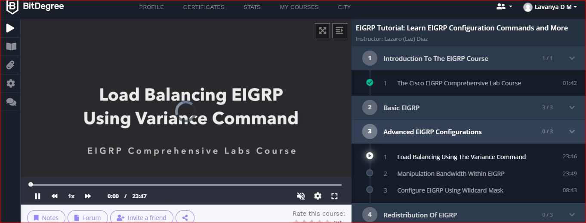

Coding Challenges Details: (Attach the snapshot and briefly write the report for the same)

**Problem 1** : Given a list of numbers, write a Python program to count Even and Odd numbers in a List.

Example: Input: list1 = [2, 7, 5, 64, 14] Output: Even = 3, odd = 2 Input: list2 = [12, 14, 95, 3] Output: Even = 2, odd = 2 Example 1: count Even and Odd numbers from given list using for loop Iterate each element in the list using for loop and check if num % 2 == 0, the condition to check even numbers. If the condition satisfies, then increase even count else increase odd count.

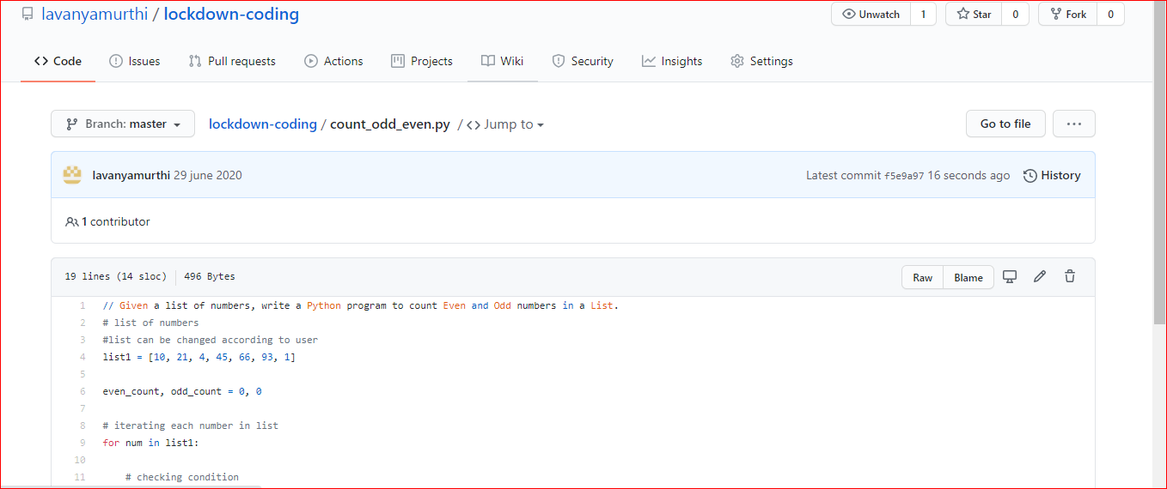

|  |
| --- |
|  |
|  |  |

**Problem 2:**  **Java program to Print Hollow Inverted Pyramid Star Pattern** 